Estimation of the Hemodynamic Response During Motor Imagery Using Bayesian RBF Neural Network

Zhengyong Pan¹, Jingna Zhang ², Wei Liao², Huafu Chen^{1*}
1 School of Applied Mathematics, University of Electronic Science and Technology of China, Chengdu 610054, China.
²Key laboratory for Neuroinformation of Ministry of Education, School of Life Science and Technology, University of Electronic Science and Technology of China, Chengdu 610054, China.

*To whom correspondence should be address: Email: chenhf@uestc.edu.cn

Abstract—Hemodynamic response during motor imagery has been studied extensively by functional magnetic resonance imaging (fMRI) technologies, but most of them are statistical parameter mapping (SPM) based. In this study, a Bayesian trained radial basis function (RBF) neural network which determines the weights and regularization parameters automatically by Bayesian learning is applied to have a precise classification of the hemodynamic response to the tasks during the motor imagery experiment. The results demonstrate that this approach could split the hemodynamic response to different task successfully.

Introduction
Functional magnetic resonance imaging (fMRI) is a technique to study the human brain functions under sensory, motor or cognitive performances. fMRI has been introduced to study motor imagery which is defined as the mental rehearsal of motor movement without any overt body movements [1,2], and also in the recovery of motor abilities in patients with movement disorders [3,4].
In data mining areas, neural networks have become more and more important tools to divide the data sets into different categories. Some familiar neural networks are usually used just as support victor machine (SVM), Gaussian Naive Bayesian Classifier, radial basis function (RBF) and so on. Recent years, these methods have been gradually used in the analysis on the fMRI signals, they can be mainly divided into two part, feature extraction and classification.
In this study, we apply a Bayesian trained RBF neural network classifier to the classification of the hemodynamic response to different tasks during the motor imagery experiment. The results show that this method is efficient and successful.

data reprocessing
Right handed subjects were asked to perform a task as follows, 4 seconds for sequence informing (visual stimuli to learn from four sequentially presented pictures, indicating a random order of finger tapping), 10 seconds for imagery, 6 seconds for motor execution, and 10 seconds for resting, in order. 10 trails fMRI data were obtained in total for left hand and right hand performances respectively under a 3.0-T scanner, GE-Signa (Huaxi MR Research Center, Chengdu, China). The gradient-recalled echo planar imaging (EPI) sequence was employed for fMRI scanning and the parameters were as follows: 30 transverse slices, TR = 2000 ms, TE = 30 ms, FOV = 24cm, matrix = 6464, voxel size = 3.753.755 mm3 (without gap), flip angle = 90°. fMRI data preprocessing was performed on software statistical parametric mapping software (SPM2, http://www.fil.ion.ucl.ac.uk/spm). In this study, only data obtained from one subject was used for example.
This work was supported by NSFC, 9082006 and 30770590, Key research project of science and technology of MOE (107097) and 863 Program No: 2008AA02Z4080.

Bayesian radial basis function

Parameters definition
The RBF nework is shown to be a good method for modeling and regression[5]. Suppose that there are N input data series (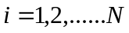), the correspondent output is taken to be a linear combination of the basis functions, i.e.,
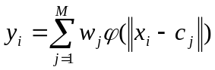 (1)
where 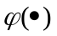 is the basic function and is the number of hidden units, 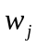's are the weights, and 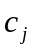is the center of the radial basis function.
To solute the weight vector and avoid the ill-posed problem, a regularization factor is introduced and then the solution to a regularized RBF network is given by:
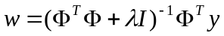 (2)
where  and  is an 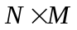 interpolation matrix with the following form:
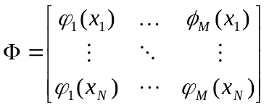 (3)
In our study, basis function is determined as a Gaussian kernel function:
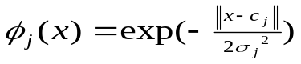 (4)
Here, 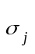 is defined as the width of theth hidden node and determined equally for different as follows:
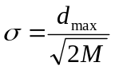 (5)
where 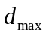 is the maximum Euclidean distance of the centers of the radial basis function.

Parameters caculation
Suppose we have got the training data set , the number of the hidden layers and the centers are obtained by applying a k-means clustering method onto the training data set. And the Gaussian width is determined according to equation (5).
In the following, the weights defined as equation (2) and the regularization factor can be determined automatically by Bayesian learning which bases on the basic idea to maximize the posterior probability over the weight vector [6,7].

Experiment data classification
  - Feature extraction
In order to train the RBF network, a set of data series were selected from the experiment time series as the features of activations. In our study, they were defined as the time series highly correlated with the task stimuli mode. This can be divided into two phases: first, three task stimuli modes, obtained by convolving the time stimuli series with the haemodynamic response (HDR) mode, are shown in Figure 1 respectively.
Second, correlation coefficients between each task stimuli mode in Figure 1 and the whole brain time series were calculated. Then, the first 100 brain time series which were the most correlated with the task stimuli mode were selected as the correspondent features of activations of the three tasks. On the other hand, the rest state feature data series were selected as the first 100 brain time series which were the least correlated with the task stimuli mode.
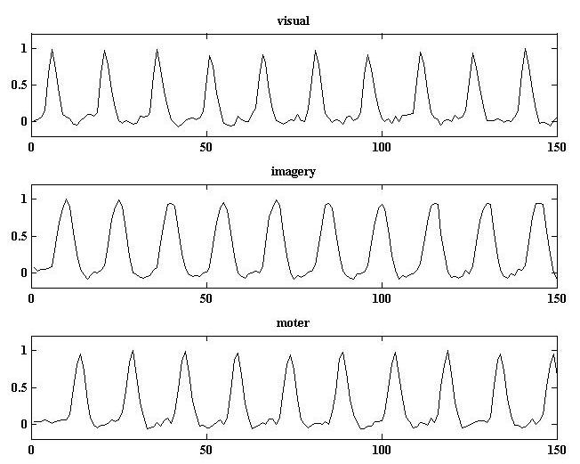Figure 1. Three task stimuli modes obtained by convolving the time stimuli series and the haemodynamic response (HDR) mode. (A) visual. (B) imagery. (C) motor.

B .Network training
Having done the feature extraction, training data set were used to form a Bayesian RBF neural network. In this network, the output was fixed to be 1 if the inputs denoted activated time series otherwise 0 if the inputs denoted the rest ones. Then, parameters such as , 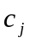, were trained using the method described in the last section. and were prepared for the subsequent data classification.

C, Data classification
For the whole brain date set classification, the time series of each voxel in the brain was used as a test data for the prepared Bayesian RBF neural network. The outputs of the whole brain data set were obtained for the activation determination. In this study, each task performance (left hand and right hand finger tap) had three kind of stimulus, the visual stimuli, imagery stimuli and the motor stimuli. Our purpose was to find out the activated areas in the brain during the correspondent task performance. The outputs of each stimuli were considered having a normal distribution, which the mean value and variance can be determined by bootstrap estimation method. 5000 times sampled results of the outputs of each stimuli are shown in Figure 2.

Activated voxels in brain areas for the correspondent task were detected from the bootstrap estimation results with a significant statistical level P<0.01. Activated regions with a threshold of the Z values of each task were shown in Figure 3.
Observed from Figure 3, we see that in the first column (see A and D), activated areas of visual task in the left and right hand task performances were almost the same, and the voxels activated almost within BRODMANN 17,18, and 19

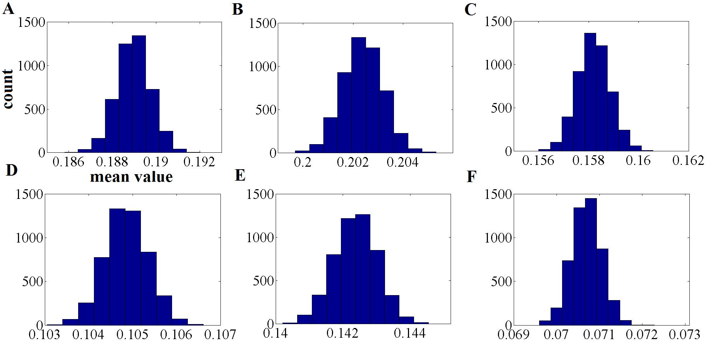
Figure 2. 5000 times sampled results of the Bayesian RBF outputs of each stimuli by bootstrap estimation method. Figures in first row are the results of visual stimuli (A), imagery stimuli (B) and motor stimuli (C) of the left-hand task performance respectively. Figures in second row are the results of visual stimuli (D), imagery stimuli (E) and motor stimuli (F) of the task-hand task performance respectively.

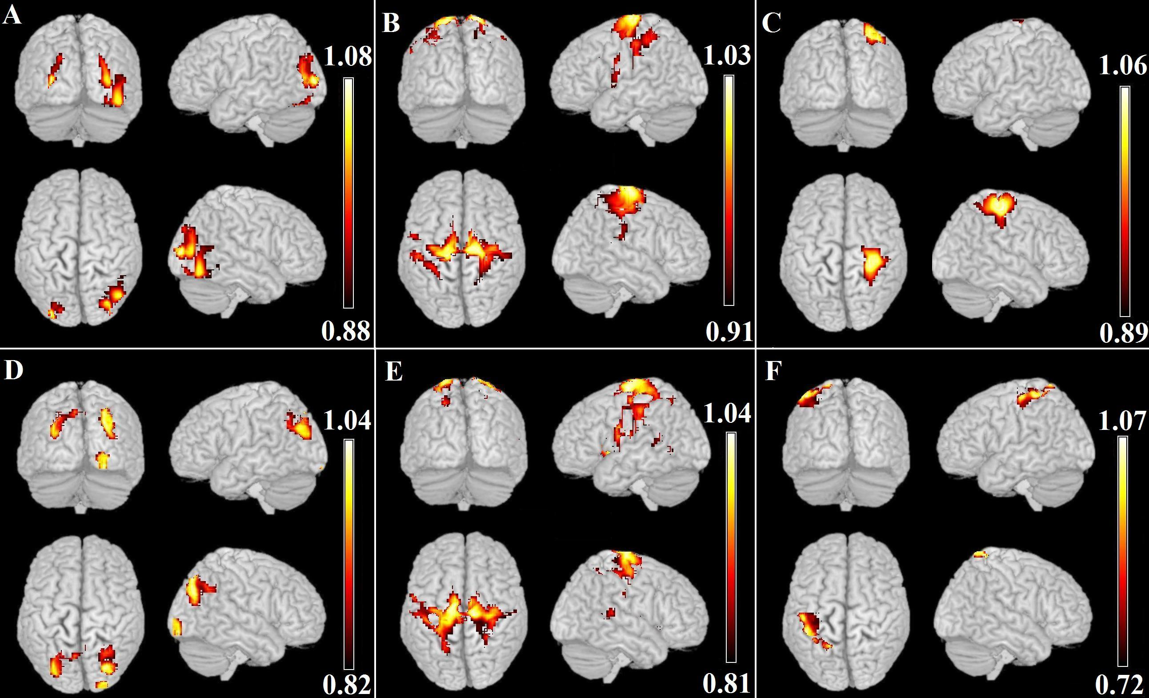
Figure 3. Correspondent activated brain areas of each task performances. Activated brain areas of the left hand performance in each task are shown in the first row and results of visual stimuli in (A), imagery in (B) and motor in (C) respectively. Activated brain areas of the right hand performance in each task are shown in the second row and results of visual stimuli in (D), imagery in (E) and motor in (F) respectively
on both sides. Also in the imagery task stage in the second column in Figure 3 (see B and E), and BRODMANN 2,3,4,6 activated on both size. But during the motor task performances (see C and F), we could see that the activated voxels concentrated in the right brain areas (almost in right BRODMANN 3,4 ) of the left finger tap task, and activated voxels concentrated in the left brain areas (almost in left BRODMANN 3,4 ) of the right finger tap task. Also, in our study, more activated brain regions were found during the left-hand motor task than in right-hand motor task. This may be due to the asymmetry of right-handedness [8] and the less lateralized activities in the motor cortex of right-handed people [9].

Conclusion
In this study, the results demonstrate that the Bayesian trained RBF neural network used in our study is efficient and capable in the classification of the data set which including different categories especially the motor imagery task fMRI data. This enhances our confidence to consider further researches on the method and more over to apply this optimized RBF neural network to the other fMRI data studies.
On the other hand, results obtained in our study enriches our understanding on the mechanism of the motor imagery in human brain. Although this is just an initial work on motor imagery, it supplies us a foundation for the further researches on the motor imagery like the functional connectivity, effective connectivity within these regions and so on. Also, other MRI techniques such as diffusion tensor imaging (DTI) could be used on the structure connectivity study on motor imagery based on our study.

References
- M. Jeannerod, Mental imagery in the motor context. Neuropsychologia. Voll.33,pp. 1419–1432, 1995
- C.A. Porro, M.P. Francescato, V. Cettolo, M.E. Diamond, P. Baraldi, C.H. Zuiani, M. Bazzocchi, P.E. di Prampero,. Primary motor and sensory cortex activation during motor performance and motor imagery: a functional magnetic resonance imaging study. J. Neurosci. Vol.16, pp.7688–7698,1996
- F. Malouin, C.L. Richards, J. Doyon, J. Desrosiers, S. Belleville, Training mobility tasks after stroke with combined mental and physical practice: a feasibility study. Neurorehabil. Neural. Repair Vol.18,pp.66–75,2004.
- T.J. Kimberley, G. Khandekar, L.L. Skraba,, J.ASpencer, E.A. Van Gorp, S.R. Walker, Neural substrates for motor imagery in severe hemiparesis. Neurorehabil. Neural. Repair Vol.20, pp.268–277,2006.
- H. Simon, Neural Networks, A comprehensive foundation.(2nd Edition)
- M. E. Tipping, “Sparse Bayesian learning and the relevance vectormachine,” Journal of Machine Learning Research, vol. 1, pp. 211-244,2001.
- E. Rank, “Application of Bayesian trained RBF networks to nonlinear time-series modeling,” Signal Processing, vol. 83, pp. 1393-1410,2003.
- L. Zeng, H. Chen, L. Ouyang, D. Yao, J-H. Gao, Quantitative analysis of asymmetry cortical activity in motor area during sequential finger movement. Magn. Reson. Imaging Vol.25, pp.1370–1375, 2007.
- S.G. Kim, J. Ashe, K. Hendrich, J.M. Ellermann, H. Merkle, K. Ugurbil, A.P. Georgopoulos, Functional magnetic resonance imaging of motor cortex: hemispheric asymmetry and handedness. Science Vol.261, pp.615–617, 1993.

